**Gordon Tregaskis – Brief Bio**

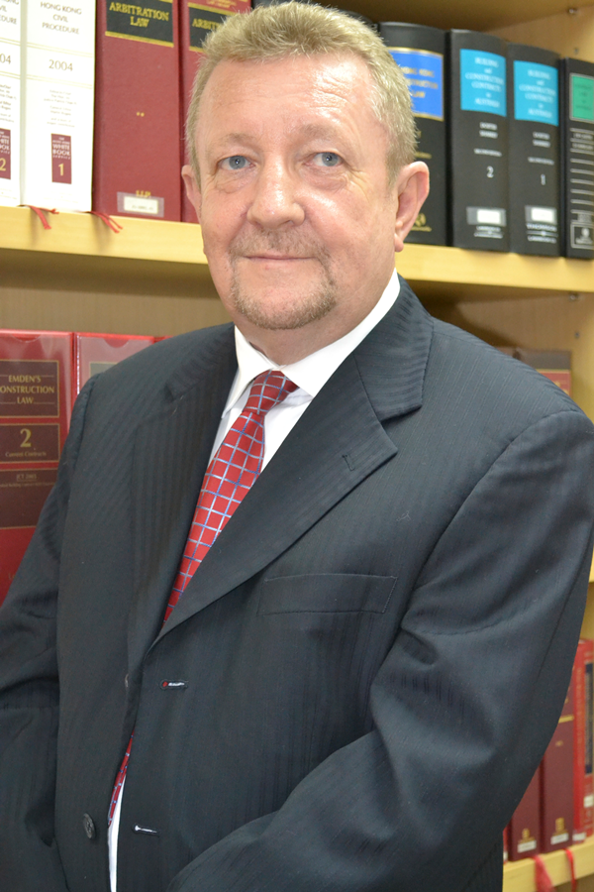

Gordon is an International Lawyer, Chartered Arbitrator, Adjudicator (CIPAA) and CEDR Solve Mediator with over 35 years’ experience of international business. He has spent the past 20 years resolving issues on major construction and/or concession projects in South East Asia, Europe, the Middle East and the Americas.

Gordon began his career as a barrister in England in 1980 before moving into the shipping and marine insurance sector where he conducted and managed many maritime and shipping arbitrations. A number of roles as a company secretary and general counsel in the aviation and industrial sectors followed, before he became the Commercial Director and CEO of various international utilities companies managing major capital projects in Australia, Indonesia, Malaysia and Thailand. Between 2007 and 2012 Gordon was active in the Middle East working for the Dubai Government as well as consulting on major regional engineering and construction contract disputes.

In 2013 Gordon turned his attention to work as a full time Neutral. As an arbitrator and mediator Gordon has recently acted as Chair or co arbitrator in arbitration proceedings in Abu Dhabi, Bangkok, Dubai and London. He and is a panel member of several world leading arbitration institutions. Gordon is solutions oriented and brings a unique understanding of cross-cultural issues to disputes or differences which may be materially and adversely affecting international business and organisations. In mediation, promoting  successful commercial settlements and outcomes is the priority. Making clear decisions in accordance with contract provisions, based on the facts established by evidence, is the priority in arbitration cases. Gordon divides his time between Asia and MENA regions where his services, experience and ADR skills are in demand

.